Mini Project Report On

## SMART ATTENDANCE MANAGEMENT SYSTEM

Submitted in partial fulfillment of the requirements for the award of the degree of

## Bachelor of Technology

In

## Department of Computer Science and Engineering

## (2020-2024)

By

|  |  |
| --- | --- |
| **G.V Harshith** | **20241A05E7** |
| **A. Sahith** | **20241A05C4** |
| **B. Shiva Krishna** | **20241A05D6** |
| **A. Guna Teja** | **20241A05C1** |
| **K. Ravi Chandra** | **21245A0516** |

Under the Esteemed guidance of

## D.USHA SREE

**(Assistant Professor, Dept of CSE)**



## Department of Computer Science and Engineering

**GOKARAJU RANGARAJU INSTITUTE OF ENGINEERING AND TECHNOLOGY**

**(Autonomous)**

**HYDERABAD**



**GOKARAJU RANGARAJU**

**INSTITUTE OF ENGINEERING AND TECHNOLOGY**

**(Autonomous)**

**CERTIFICATE**

This is to certify that the mini-project titled "Smart Attendance Management System" has been submitted by **G.V. Harshith (20241A05E7), A. Sahith (20241A05C4), B. Shiva Krishna (20241A05D6), A. Guna Teja (20241A05C1), and K. Ravi Chandra (21245A0516).** This submission is made in partial fulfillment of the requirements for the degree of Bachelor of Technology in Computer Science and Engineering for the academic year 2022-2023.

INTERNAL GUIDE HEAD OF THE DEPARTMENT

## D.USHA SREE Dr. K. MADHAVI

**Assistant Professor Professor & HOD**

EXTERNAL EXAMINER

## ACKNOWLEDGEMENT

We would like to express our heartfelt gratitude to all those who directly and indirectly contributed to the successful completion of our project. First and foremost, we would like to extend our deepest appreciation to our internal guide, **D. USHA SREE, Assistant Professor**, Department of CSE, for his invaluable support in completing our project report. We are also immensely grateful to **Dr. K. Madhavi, HOD, Department of CSE**, and our principal, Dr. J. Praveen, for providing us with the necessary facilities to successfully complete our mini project. Their assistance has been instrumental in our achievements. Furthermore, we would like to thank all the faculty members and friends who supported us throughout the project completion phase. Their help and constructive criticism have played a significant role in shaping our project. Lastly, we owe a tremendous debt of gratitude to our parents for their unwavering moral support and constant encouragement in helping us achieve our goals.

###### G.V. HARSHITH - 20241A05E7

1. **SAHITH - 20241A05C4**

###### SHIVA KRISHNA - 20241A05D6

**A. GUNA TEJA - 20241A05C1**

**K. RAVI CHANDRA - 21245A0516**

## DECLARATION

We hereby declare that the project titled "**Smart Attendance Management System**" is the result of our own original work. It has been completed as a part of our academic requirements for the degree of Bachelor of Technology in Computer Science and Engineering. Our project work is done during the period from **12th Jan 2023 to 3rd June 2023** from Gokaraju Rangaraju Institute of Engineering and Technology (Autonomous under Jawaharlal Nehru Technology University, Hyderabad). Throughout the development process, we have followed ethical practices and taken necessary measures to protect the privacy and security of individuals' facial data. Any data collected and stored during the project has been handled in compliance with applicable privacy regulations and guidelines. We also acknowledge the guidance and support received from our internal guide, faculty members, and the institute during the course of this project. Their insights and suggestions have been instrumental in the successful completion of this endeavour.

###### G.V. HARSHITH - 20241A05E7

1. **SAHITH - 20241A05C4**

###### SHIVA KRISHNA - 20241A05D6

**A. GUNA TEJA - 20241A05C1**

**K. RAVI CHANDRA - 21245A0516**

|  |  |  |
| --- | --- | --- |
|  | **Table of Contents** |  |
| **Chapter** | **TITLE** | **Page No** |
|  | **Abstract** | VIII |
| **1** | **Introduction** | 1 |
|  | 1.1ExistingSystem | 1 |
|  | 1.1.1 Limitations in Existing System | 1 |
|  | 1.2 Proposed System | 1 |
|  | 1.2.1 Advantages over Existing System | 1 |
| **2** | **Literature Survey** | 2-3 |
| **3** | **Software Requirement Specifications** | 4-9 |
|  | 1. **Introduction**    1. Purpose of the requirements document    2. Scope of the product    3. Definitions, acronyms and abbreviations    4. References    5. Overview of the remainder of the document 2. **General description**    1. Product perspective    2. Product functions    3. User characteristics    4. General constraints    5. Assumptions and dependencies 3. **Specific requirements** 4. Software Requirements 5. Functional Requirements 6. Non-Functional Requirements |  |
|  | 3.4 Feasibility Study | 9 |
|  | 3.4.1 Technical Feasibility | 9 |
|  | 3.4.2 Economic Feasibility | 9 |
|  | 3.4.3 Operational Feasibility | 9 |
| **4** | **Design** | 10-16 |
|  | 4.1 Project Description | 10 |
|  | 4.1.1 System Use case Diagrams | 11-14 |
|  | 4.1.2 Class Diagrams | 14 |

|  |  |  |
| --- | --- | --- |
|  | 4.1.3 Data Flow Diagram (DFD) | 15 |
| **5** | **Implementation** | 16 |
|  | * 1. Source code   2. Results | 16-22  22-24 |
| **6** | **Testing** | 25 |
|  | **Test Cases** |  |
| **7** | **Conclusion& Future Scope** | 26 |
|  | **References** | 27 |

**List of Figures**

|  |  |  |
| --- | --- | --- |
| **Fig No** | **Fig Title** | **Page no** |
| 4.1.1 | System Architecture | 10 |
| 4.1.1.1 | Use Case Diagram for Student Enrolment | 11 |
| 4.1.1.2 | Use Case Diagram for Preprocessing and training the model | 12 |
| 4.1.1.3 | Use Case Diagram for Testing the Model | 13 |
| 4.1.2.1 | Class Diagram | 14 |
| 4.1.3.1 | Data Flow Diagram | 15 |
| 5.2.1 | Facial Recognition | 22 |
| 5.2.2 | Attendance Status (Present/Absent) | 23 |
| 5.2.3 | Marking the Attendance in Excel Sheet | 23 |
| 5.2.4 | Multiple Face Recognition | 24 |
| 5.2.5 | Marking the Attendance in Excel Sheet | 24 |

**List of Tables**

|  |  |  |
| --- | --- | --- |
| **Table No** | **Title of the Table** | **Page no** |
| 6.1 | Testing for different Inputs | 25 |

;l

## ABSTRACT

We have proposed an automatic attendance system that utilizes machine learning techniques, specifically the CNN algorithm. This system aims to automate the process of marking attendance by leveraging face detection and recognition technology to identify students present in the classroom. During class hours, the system captures images using a camera, detects and segments faces, and applies the Convolutional Neural Network (CNN) for face verification. Our project introduces an OpenCV-based face recognition approach, which integrates a camera for image capture, algorithms for face detection, encoding, and identification, attendance logging in a spreadsheet, and conversion into a PDF file. To train the system, we create a database by training it with the faces of authorized students. These cropped images are then stored in the system's database for reference.

Attendance management is a crucial function in educational institutions as it allows monitoring of system performance. While different institutions have their own methods of maintaining attendance records, our proposed facial recognition system offers an efficient application for this purpose. It utilizes computerized software to determine or validate a person's identity by comparing patterns based on facial appearance.

## CHAPTER 1

## INTRODUCTION

* 1. **Existing System**
     + In Schools, workplaces and in many events, attendance is considered with the help of manual sign in sheet.
     + Radio Frequency Identification cards are used in some organizations. To mark attendance tags are scanned at entry polls which records attendance automatically.
     + In Educational Institutions Attendance Registers are used to mark students whether they are present or absent during each class.

## Limitations in Existing System

* + - * The Manual method of attendance leads to the marking of proxy attendance even when they are absent.
      * Manipulation takes place on the manual sign-in sheet, and all the other existing systems are time consuming and susceptible to errors.
      * Human errors in marking attendance can result in incorrect records.

# Proposed System

* + - Face recognition-based attendance marking system is introduced.
    - It uses the most popular algorithm, CNN (mobilenetv2), to mark attendance based on face identification.

# Advantages over Existing System

* It aims to ease the attendance process, which takes a lot of time, and reduce proxy marking.
* Human errors will not affect the attendance records of students, etc.
* It increases the level of security with the help of unique identifications.

## CHAPTER 2

## LITERATURE SURVEY

In 2012, Alex Krizhevsky's implementation of CNN had a profound impact on researchers, changing their perception of this model. Since then, there have been significant advancements in CNN by replacing manually designed techniques, leading to notable improvements in various pattern recognition tasks. Karol J. Piczak proposed a deep model that includes two convolutional layers, max pooling layers, and two fully connected layers. This model is trained on a low-level representation of audio data. J. Salamon and J.P Bello introduced a deep CNN architecture for environmental sound classification, which consists of three convolutional layers interleaved with two max pooling operations. This architecture is followed by two fully connected layers. To address the data scarcity issue in the dataset, they also suggested utilizing audio data augmentation techniques.

Smart Attendance Management System (SMAS), which employs face detection technology, has gained significant attention as a reliable and efficient method for automating attendance tracking processes. This overview provides a comprehensive management system using face detection. Face detection is a computer vision technique that involves locating and identifying human faces within images or video streams. The overview covers various face detection algorithms, such as Viola-Jones, Histogram of Oriented Gradients (HOG), and deep learning-based approaches. It also introduces pre-processing techniques for face detection, including image normalization and face alignment. The components of a Smart Attendance Management System include System Architecture, Face data collection and enrolment, Real- time face detection and recognition, and attendance tracking and recording.

The rate of accuracy for individual CNN model has 75% before implementing the techniques in it. After implementing some techniques like face detection etc, in CNN had increased up to 90% without overfitting the model on the training set. The face detection technology enables precise identification and verification of individuals, minimizing errors and fraudulent activities. By automated face detection speeds up the attendance tracking process, reducing administrative workload, and saving time will increase the time efficiency. By eliminating the need for manual paper-based systems or additional hardware, resulting in cost savings. Face detection adds on extra layer for security by ensuring that only authorized individuals are present for attendance.

There are more challenges and conditions to detect the faces in variations in lighting conditions and environmental factors may affect the accuracy of face detection algorithms. The collection and storage of facial data raise privacy and security concerns, necessitating robust data protection measures. Some individuals may have concerns about the use of facial recognition technology, highlighting the need for transparent communication and user consent. To address these challenges and conditions, we have implemented a model called MobileNetV2. MobileNetV2 is a convolutional neural network (CNN) architecture specifically designed for efficient and lightweight image classification tasks. It serves as an extension of the original MobileNetV2 architecture, with the goal of further reducing computational complexity and model size while maintaining competitive accuracy.

MobileNetV2 is specifically optimized to be lightweight, making it well-suited for deployment on resource-constrained devices such as mobile phones or edge devices. It achieves this by employing several key techniques, including depth-wise separable convolutions, inverted residuals, linear bottlenecks, and shortcut connections. These techniques enable MobileNetV2 to strike a good balance between model size and accuracy. It’s advantages lie in its small model size, reduced computational complexity, and suitability for mobile and embedded device applications. The model size is significantly smaller compared to larger CNN architectures like VGG or ResNet. It reduces the computational complexity by leveraging depth wise separable convolutions and inverted residual blocks, MobileNetV2 reduces the number of parameters and computations required during both training and inference. This enables faster inference times and reduced memory footprint, making it ideal for real-time or embedded applications. Although MobileNetV2 sacrifices some accuracy compared to larger and more complex CNN models, it still achieves competitive performance on image classification tasks while offering significant advantages in terms of model size and computational efficiency. MobileNetV2's efficiency and small model size make it well-suited for various applications, such as it enables real-time image classification on mobile phones, IoT devices, and edge devices with limited computational resources. It can serve as a base network for transfer learning, where its pre-trained weights can be fine-tuned on specific tasks or datasets. Indeed, MobileNetV2 also functions as a reference model for implementing model compression techniques, including quantization and pruning. These techniques are utilized to further decrease the model size and computational demands while maintaining the essential features and performance of the model.

The significance of accurate and efficient attendance tracking in various sectors, such as education, corporate organizations, and government institutions. Challenges associated with traditional manual attendance management method. There are some examples for successful implementations of smart attendance management systems using face detection in various sectors, such as schools, universities, and organizations. Evaluation of system performance, user satisfaction, and impact on attendance management processes. Advancements in face detection algorithms and techniques, such as deep learning-based approaches, to improve accuracy and robustness. Integration with other biometric modalities, such as fingerprint or iris recognition, for multi-factor authentication. Exploration of cloud-based or edge computing solutions for scalability and real-time processing. Ethical and legal considerations in the use of face detection technology, including privacy regulations and user consent.

This overview highlights the significance of smart attendance management systems using face detection in various sectors. It discusses the components, benefits, challenges, and future directions of such systems. By leveraging face detection technology, organizations can streamline attendance tracking processes, improve accuracy, and enhance overall efficiency.

## CHAPTER 3

## Software Requirement Specifications

1. **Introduction**

## Purpose of the requirements document:

* + - The aim of our endeavour is to maintain attendance records effectively and safely increase attendance precision, resulting in advantages for employers, events, colleges, and schools.
    - It can able to identify people based on their facial personality characteristics.
    - The technique done rid all the requirement on individual note performing saving both educators and pupils both time and effort while class it provides a simpler and more efficient a position for tracking presence.

## Scope of the Project:

* + - The scope of the Smart Attendance Management System is to provide automate the method of considering of attendance.
    - This project helps to know the number of students present in the classroom by keeping track of their face detection and recognition algorithms.
    - It can be adaptable to any kind of educational institutions with different class sizes.
    - This aspect permits Immediate action in instances if unusual events or troubles appear.

## Definitions, acronyms, and abbreviations:

**DEFINITIONS**:

**OpenCV:**

It is an open-source computer vision algorithm for capturing and displaying our required content on the computer screen window. So, OpenCV is an important algorithm for the project implementation.

**CNN:**

CNN is a popular deep learning algorithm primarily utilized for image classification and identification tasks. Its algorithms and techniques have been widely employed in various domains to achieve accurate and efficient image analysis and recognition.

**MobileNetV2:**

It is an architecture of CNN which uses depth wise convolutions. It can be used for large dimensions images. It can be easily handled in mobiles too.

###### TensorFlow and Kera’s:

Used for training and deploying the face recognition model. It is also an deep learning framework.

###### NumPy:

It is generally defined as numerical python which stores output using OpenCV.

## Acronyms and abbreviations:

###### OpenCV:

Open-Source Computer Vision.

###### CNN:

Convolutional Neural Network.

###### NumPy:

Numerical Python.

## References:

* + - N. I. Zainal, K. A. Sidek, and T. S. Gunawan presented a paper titled "Design and Development of a Classroom Attendance System Based on Arduino and Fingerprint Biometric" at the 6th IEEE International Conference on Information and Communication Technology. The conference proceedings were held on November 17-18, 2014
* Kadry, Mohamad. Smaili, "Wireless attendance management system based on iris recognition", Scientific Research, p. 1428-1435, 2013.
* M.N. Yeop Sabri, M.Y.A. Abdul Azis, M.R.R. Mohammad Shah, M.F Abdul Kadeer, "Smart Attendance System by using RFID.

## Overview:

Basically, to overcome the manual attendance sheet records, we have introduced our project it uses mobilenetv2 which is one of the deepest Convolutional Neural Network architectures. Generally, to overcome the ancient problems the attendance is taken into consideration by following some common steps which are somewhat difficult in implementing but it can reduce later inappropriate records of attendance marking of presenters. The following four steps are included in our project:

* + - Data Base Creation
    - Preprocessing Data
    - Training Database
    - Testing Database

To implement project, database must be created. Initially some student’s facial characteristics have to be stored in database with subfolders named with their respective identification identity. The data which has been stored in databases is pre-processed with our algorithms like mobileNetV2 before preprocessing, each student images have been taken into consideration and near to 500 images has taken to get more appropriate accuracy in regarding of attendance. After consideration images have pre-processed and their facial characteristics has stored with respective to their identity.

Pre-processed images are considered into training dataset. Initially images are taken in the form of grey scales which are converted into required colour images with respective of our needs. As the images are stored in different formats they are converted into black and white images which are useful in storing them in matrix with binary values such as 1 or 0. To change them into their respective colour they are divided by certain number but in our project, we have been used number as 415.The reason behind of using this specific number is to get more accuracy than existing algorithms.

After completion of preprocessing, data has trained. In testing of attendance, the above steps are used to mark attendance in excel sheet corresponding to their identity even with the multiple faces.

## General description:

* + - * 1. **Product perspective:**

Productive perspective of our project using facial identification using one of the deepest Convolutional Neural Network basically consists of 53 layers which uses both point and depth layers. This works independently without depending on the external systems.

## Product functions:

It uses many product functions to mark attendance. The following are the some of the most functions in our project:

* + - System Maintenance and Support
    - Attendance Marking
    - Facial recognition
    - Attendance Reports
    - Database Management
    - System Configuration
    - Attendance Marking
    - Face Detection
    - System Configuration
    - Camera Integration
    - Attendance Marking
    - User Management

The above-mentioned functionalities provide the best outcome with required things for marking and maintaining number of students in the class with their identification identity. It gives output with more precision and it handles in all educational institutions.

## User characteristics:

To implement project in user-friendly and in easy way we have considered very new technical skills and some more responsibilities which provides better documentation and gives resources which are already trained. It consists of following important characteristics:

* Students
* System users with Administrative Rights
* Administrators
* IT personnels
* Instructors
* System operators

## General constraints:

While doing we have identified many general constraints. So, to overcome them in an efficient way and to produce among the best system into the market we have used mobilenetv2 which is reliable and user-friendly. It reaches the expectations of all the users like educational institutions.

Some of the common constraints with regarding of our experiment are:

* Maintenance and Upgrades
* Privacy and Data Protection
* User Acceptance and Training
* Environmental Factors
* Cost Constraints
* Ethical Considerations
* Hardware Limitations
* Scalability and Performance
* Integration with Existing Systems

## Assumptions and dependencies:

## Assumptions:

Based on the project the assumptions may vary like while considering some special needs and context of the project. These plays an important role in developing project it serves as starting point to improve the existing project with some more specifications which will be adjusted while implementing. Some of the most common assumptions are highlighted in below:

* + - Adequate User Training and Support
    - Reliable Camera Availability
    - Compliance with Legal and Privacy Requirements
    - Authorized Database of Students
    - Reliable Network Connectivity
    - Student Cooperation
    - Sufficient Computing Resources
    - Adequate Training Data

### Dependencies:

##### There are many dependencies that have to be taken into consideration while implementing this. It can any like external or resources the system depends on to work in an appropriate way.

We have many dependencies which should be found and integrated to ensure a smooth management system without any faults.

##### Here are some of them:

* + - User Training and Support
    - Image Processing Libraries
    - Hardware Resources
    - Convolutional Neural Network (CNN) Framework
    - Integration with Attendance Management Systems
    - Compliance with Regulations and Policies
    - Training Data
    - Network Connectivity
    - Camera Infrastructure
    - Storage Infrastructure

## Specific Requirements:

* 1. **Software Requirements**

##### Operating System : Windows or Mac OS Platform : VS code, IDLE Programming Language: Python

* + 1. **Functional Requirements**

To document the functional requirements, it is essential to specify the set of functionalities supported by the system. Each function can be defined by identifying the state at which data is inputted into the system, the input data domain, the output domain, and the type of processing

required to obtain the output data. Functional requirements serve to define the specific behavior and functions of the application. Following are the functional requirements:

* + - 1. System Maintenance and Support
      2. Database Management
      3. Face Detection
      4. Attendance Marking
      5. Data Security and Privacy
      6. Database Management
      7. Real-Time Monitoring
      8. Attendance Reports
      9. Facial Recognition
    1. **Non-Functional Requirements**

A non-functional requirement is a type of requirement that outlines criteria used to evaluate the operation of a system, focusing on constraints that the system must adhere to, rather than specific behaviours. These requirements define the operational boundaries within which the system must function. Following are the non-functional requirements:

* Compatibility
* Integration
* Usability
* Performance
* Compatibility
* Security
* Maintainability
  1. **Feasibility Study**

It helps in finding success of a project. It determines whether our project is helpful to economic and scheduling considerations.

#### Technical Feasibility

Examination of the its technical details and abilities including the supply of the required tools resources and technologies analysis of the visage recognition algorithms scalability and integration of the digital camera facilities computing libraries thus and a system for the management a probe of the skills and talents required system building and sustaining it.

### Economic Feasibility

In assessing the project's profitability, it is crucial to consider the expenses related to software development, hardware acquisition, and maintenance, while also examining the potential time and cost savings that could result from digitizing time management tasks. Furthermore, an analysis of the feasibility and associated costs for implementing and operating this digital solution within the educational institution is necessary.

#### Operational Feasibility

To analyse operating feasibility on the project of this we assigned needs of the educational institutions and analysed for system implementation

## CHAPTER 4

## DESIGN

1. **Project Description:**

## Architecture:

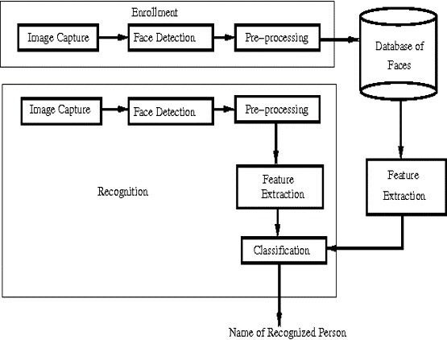

Fig-4.1.1

An architectural description is a formal depiction of a system intended to facilitate the analysis of its structural attributes. It delineates the system's components or building blocks and outlines a strategy for procuring products and developing systems that can collaborate to implement the overall system. This enables effective management of investments in alignment with the organization's specific requirements.

Our architecture will explain how it processed and detect the faces of students in the classroom. Provides an interface for administrators, teachers, and students to interact with the system. It stores user information such as names, unique identifiers, and facial templates. Maintains attendance records, including timestamps and related information. Utilizes face detection techniques to detect and locate faces in images or live video streams. Extracts facial features and prepares the data for the face recognition module. Compares the extracted facial features with the facial templates stored in the database. Determines the identity of each detected face by matching it with the registered users. Records the attendance status (present/absent) of each recognized individual.

### System Use Case Diagrams:

###### USE CASE DIAGRAM FOR STUDENT ENROLLMENT

Fig-4.1.1.1

In the above figure it consists of 3 main actors:

* + - * Faculty: This actor will enter the student details to save their data in dataset.
      * System: The system initializes the camera and capture the images of student and creates a folder with their respective registered number.
      * Student: The actions of this actor is same as like faculty.

In the above diagram 3 actors can perform the following Use Cases:

* + - * Enter the Roll No: It is used to enter the details of student
      * initialize camera: It will initialize the camera when the details are entered.
      * Capturing images: It captures the images of students faces up to 500.
      * Folder Creation: Then it creates the dataset folder with the registered roll numbers.
      * Storing images: It stores all that images in that folder.

###### USE CASE DIAGRAM FOR PREPROCESSING AND TRAINING THE MODEL

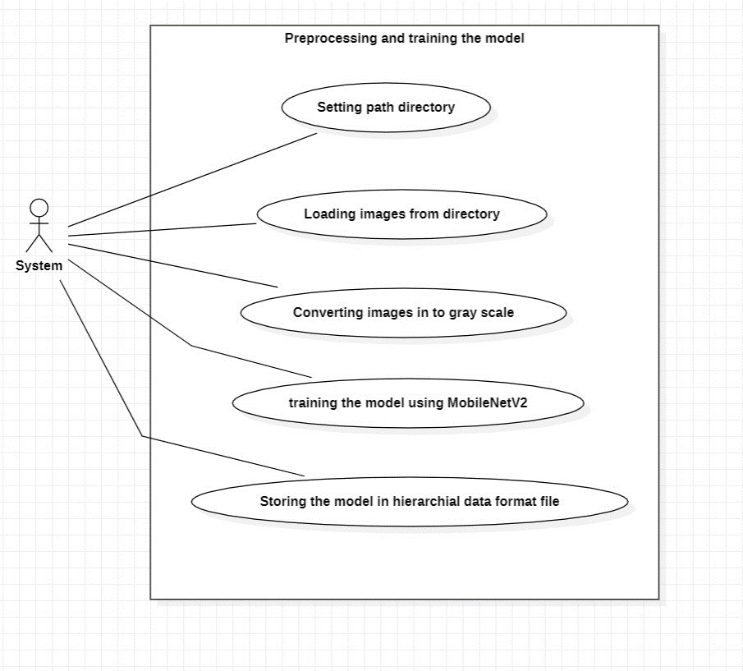

Fig-4.1.1.2

In the above figure it consists of 1 main actors:

* + - * System: This actor will do the process step by step without any human involvement.

In the above diagram single actor can perform the following Use Cases:

* + - * Setting directory: It will set the directory for the saved folder.
      * Loading images from directory: It loads the images from directory path.
      * Converting images into grey scale: It will convert the saved images into grey scale for better classification.
      * Training the Model: This model is used to train the converted images.
      * Storing the model: This will store those images in hierarchical data format file.

###### USE CASE DIAGRAM FOR TESTING THE MODEL

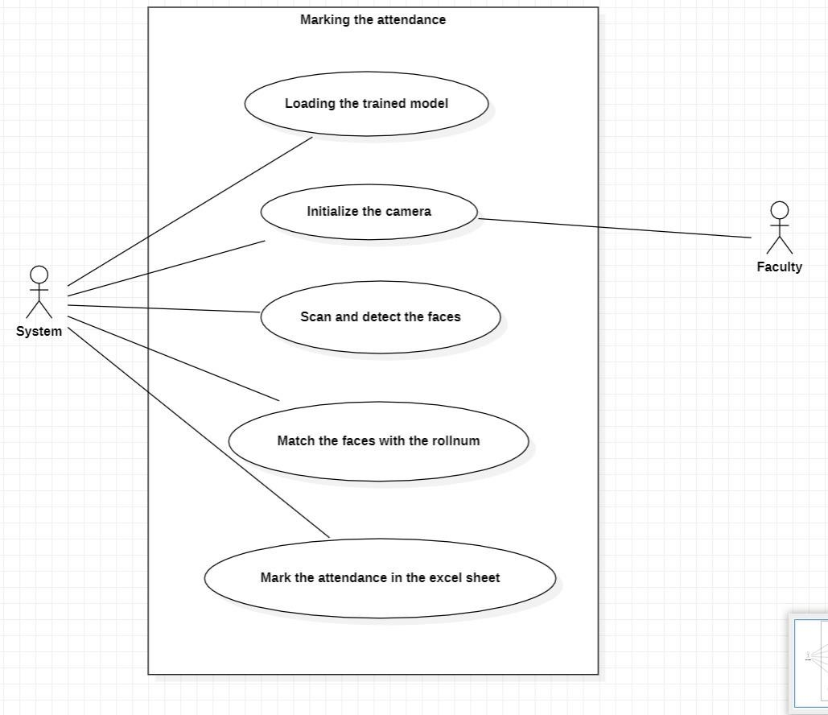

Fig-4.1.1.3

In the above figure it consists of 2 main actors:

* + - * System: It will load, initializes, scan and match the face images and mark the attendance.

In the above diagram single actor can perform the following Use Cases:

* + - * Loading the train model: It load the trained model for testing.
      * Initialize camera: It will initialize the camera for again to capture the image.
      * Scan and detect camera: The system will scan and detect the captured image.
      * Matching faces: This will match the captured image with the stores the images.
      * Marking attendance: Then The attendance will be marked in excel sheet.

## Class Diagram

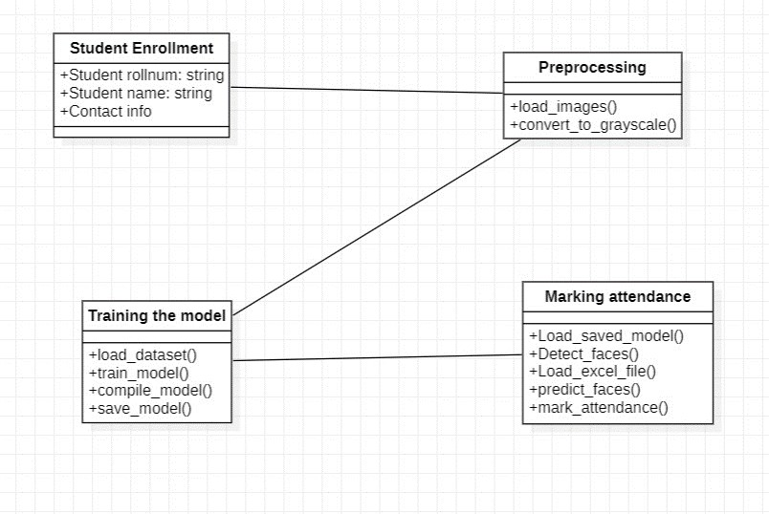

Fig-4.1.2.1

In the above class diagrams, there are 4 classes:

Student Enrollment :

Attributes: student_rollnum, student_name,contact info are the attributes for storing student details.

Preprocessing:

Methods:load_images(),convert_to_grayscale() are the methods used to load the images convert in to grayscale to preprocess the images.

Training the model:

Methods: load_dataset(), train_model(), compile_model(), save_model() are the methods used to load the dataset, train the model and save the model in a hierarchical data format file.

###### Marking Attendance:

Methods: load_saved_model(), detect_faces(),predict_faces(),mark_attendance() are the methods used to load the saved model and detect the faces and predict the faces and mark the attendance in the excel sheet.

## Data Flow Diagram

DFDs capture the techniques employed within a system to facilitate the seamless movement of data from input sources to file storage and report generation. There are two primary types of DFDs: logical and physical. A logical data flow diagram illustrates the flow of data in relation to specific business functions within the system. It provides a conceptual representation of how data moves within the system to support various activities and processes. In contrast, a physical data flow diagram showcases the actual implementation and execution of the logical data flow. It depicts the practical aspects, such as the hardware, software, and network components involved in the data flow.

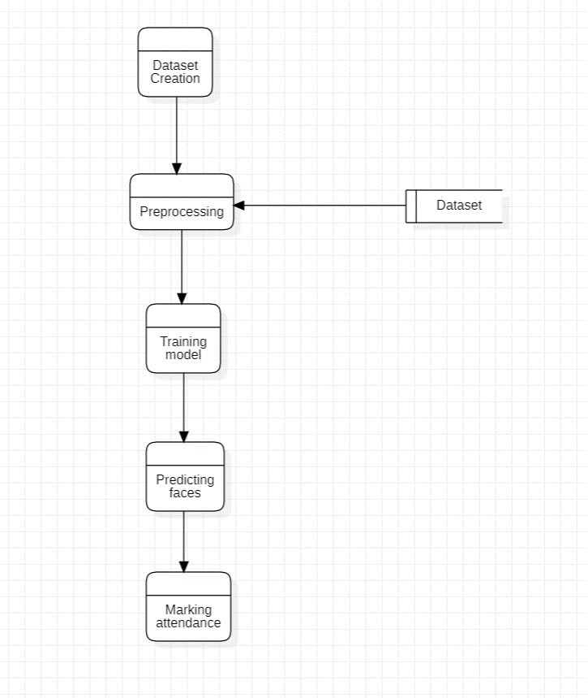

Fig-4.1.3.1

## CHAPTER 5

## IMPLEMENTATION

### Steps:

1. Importing the required libraries and modules.

**Datasetcreation.py**

import cv2 import os7

1. Entering the student details for creating a folder with the student roll number
2. Initializing the camera to capture the images of the student and store in the folder with student roll number.
3. After storing the student individual images preprocess the images of the students.
4. Now, train the model by using MobileNetV2 algorithm.
5. Store the trained model in a hierarchical data format file as it stores efficiently the trained model.
6. After storing the trained model load the excel file and the trained model for testing.
7. Initialize the camera to scan and detect the faces of the students present in front of the camera
8. Classify the students according to their roll numbers.
9. After classifying the students, mark the attendance to the students present in the class in the excel sheet by creating a new column with the column name as the todays date.
10. And the attendance is marked in the excel sheet for the students present in the class.
    * + 1. **Source Code**

### Datasetcreation.py

import cv2 import os

directory = 'D:/Downloads/project/dataset'

student_name = input("Enter the student's name: ")

student_directory = os.path.join(directory, student_name) if not os.path.exists(student_directory):

os.makedirs(student_directory)

cascade_classifier=cv2.CascadeClassifier(cv2.data.haarcascades+ 'haarcascade_frontalface_default.xml')

capture = cv2.VideoCapture(0)

count = 0

while count < 450:

ret, frame = capture.read() frame=cv2.flip(frame,1)

if not ret: break

gray = cv2.cvtColor(frame, cv2.COLOR_BGR2GRAY)

faces = cascade_classifier.detectMultiScale(gray, scaleFactor=1.3, minNeighbors=5)

for (x_cord, y_cord, width, height) in faces:

cv2.rectangle(frame, (x_cord, y_cord), (x_cord+width, y_cord+height), (0, 255, 0), 2)

face_img = frame[y_cord:y_cord+height, x_cord:x_cord+width]

filename = os.path.join(student_directory, f'{student_name}_{count}.jpg') cv2.imwrite(filename, face_img)

count += 1

cv2.imshow('capture Images', frame) if cv2.waitKey(1) & 0xFF == ord('q'):

break

capture.release() cv2.destroyAllWindows()

**Training.Py**

import os

import cv2

import numpy as np

from tensorflow import keras

from keras.preprocessing.image import ImageDataGenerator

from keras.applications import MobileNetV2

from keras.layers import Dense, GlobalAveragePooling2D

from keras.models import Model

data_path = 'D:/Downloads/project/dataset'

image_size = (224, 224)

def preprocess_image(img):

img = img.astype(np.float32) / 255.0

return img

training_data_generation=ImageDataGenerator(rotation_range=10,width_shift_range=0.1,height_shift_range=0.1,shear_range=0.1,zoom_range=0.1,horizontal_flip=True,validation_split=0.2,preprocessing_functio n=preprocess_image)

training_data=training_data_generation.flow_from_directory(data_path,target_size=image_size,batch_size=32,class_mode='categorical',subset='training')

validation_data=training_data_generation.flow_from_directory(data_path,target_size=imagesize,batch_size=32,class_mode='categorical',subset='validation')

base_model=MobileNetV2(weights='imagenet',include_top=False, input_shape=(224, 224,

3))

for layer in base_model.layers:

layer.trainable = False

x = base_model.output

x = GlobalAveragePooling2D()(x) x = Dense(128, activation='relu')(x)

predictions = Dense(training_data.num_classes, activation='softmax')(x)

model = Model(inputs=base_model.input, outputs=predictions)

model.compile(optimizer='adam',loss='categorical_crossentropy',metrics=['accuracy'])

model.fit(training_data,validation_data=validation_data,epochs=30)

model.save('trained_model.h5')

### Marking_attendance.Py

import cv2

import os

import numpy as np

import pandas as pd

import datetime import time

from tensorflow import keras

from keras.models import load_model

model = load_model('trained_model.h5')

cascade_classifier=cv2.CascadeClassifier(cv2.data.haarcascades+'haarcascade_frontalface_default.xml')

directory="D:/Downloads/project/dataset"

entries = os.listdir(directory) roll_nums=[]

for entry in entries:

if os.path.isdir(os.path.join(directory, entry)):

roll_nums.append(entry)

print(roll_nums)

attendance_sheet=pd.read_excel('attendance.xlsx')

if os.path.exists('attendance.xlsx')

else pd.DataFrame(columns=['Name'])

todays_date = datetime.date.today().strftime('%Y-%m-%d') capture = cv2.VideoCapture(0)

duration = 20

end = time.time() + duration

attendance = {label: 0 for label in roll_nums} print(attendance)

while (time.time()) < end: ret, frame = capture.read() frame=cv2.flip(frame,1) if not ret:

break

gray = cv2.cvtColor(frame, cv2.COLOR_BGR2GRAY)

faces=cascade_classifier.detectMultiScale(gray,scaleFactor=1.1, minNeighbors=5)

for (x_cord, y_cord, width, height) in faces:

captured_img = frame[y_cord:y_cord+height, x_cord:x_cord+width]

captured_img = cv2.resize(captured_img, (224, 224)) captured_img = captured_img / 255.0

captured_img = np.expand_dims(captured_img, axis=0)

probability = model.predict(captured_img)

class_idx = np.argmax(probability) class_label=roll_nums[class_idx] attendance[class_label] += 1

cv2.rectangle(frame, (x_cord, y_cord), (x_cord+width, y_cord+height), (0, 255, 0), 2) cv2.putText(frame,class_label,(x_cord,y_cord-10),cv2.FONT_HERSHEY_SIMPLEX,

0.9, (0, 255, 0), 2)

cv2.imshow('Attendance', frame)

if cv2.waitKey(1) & 0xFF == ord('q'): break

capture.release() cv2.destroyAllWindows()

max_count=max(attendance.values()) #print(attendance)

for label, count in attendance.items(): if count >= (max_count*0.6):

attendance_sheet.loc[attendance_sheet['Name'] == label, todays_date] = 'Present' else:

attendance_sheet.loc[attendance_sheet['Name'] == label, todays_date] = 'Absent'

attendance_sheet.to_excel('attendance.xlsx', index=False)

print("Attendance updated for", todays_date) print(attendance_sheet)

## Results :

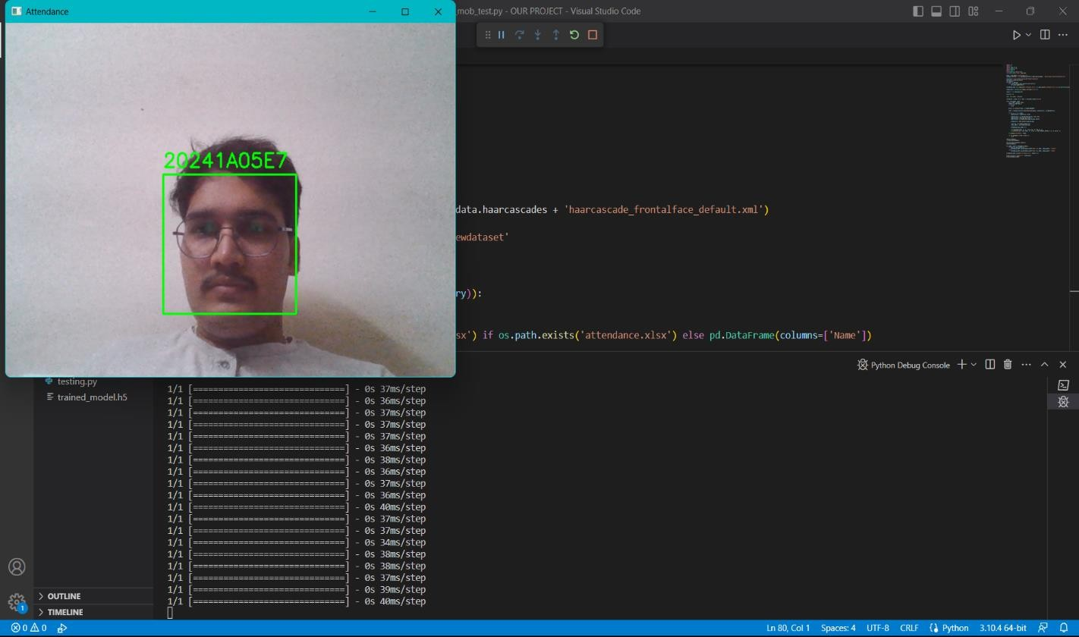

Fig-5.2.1

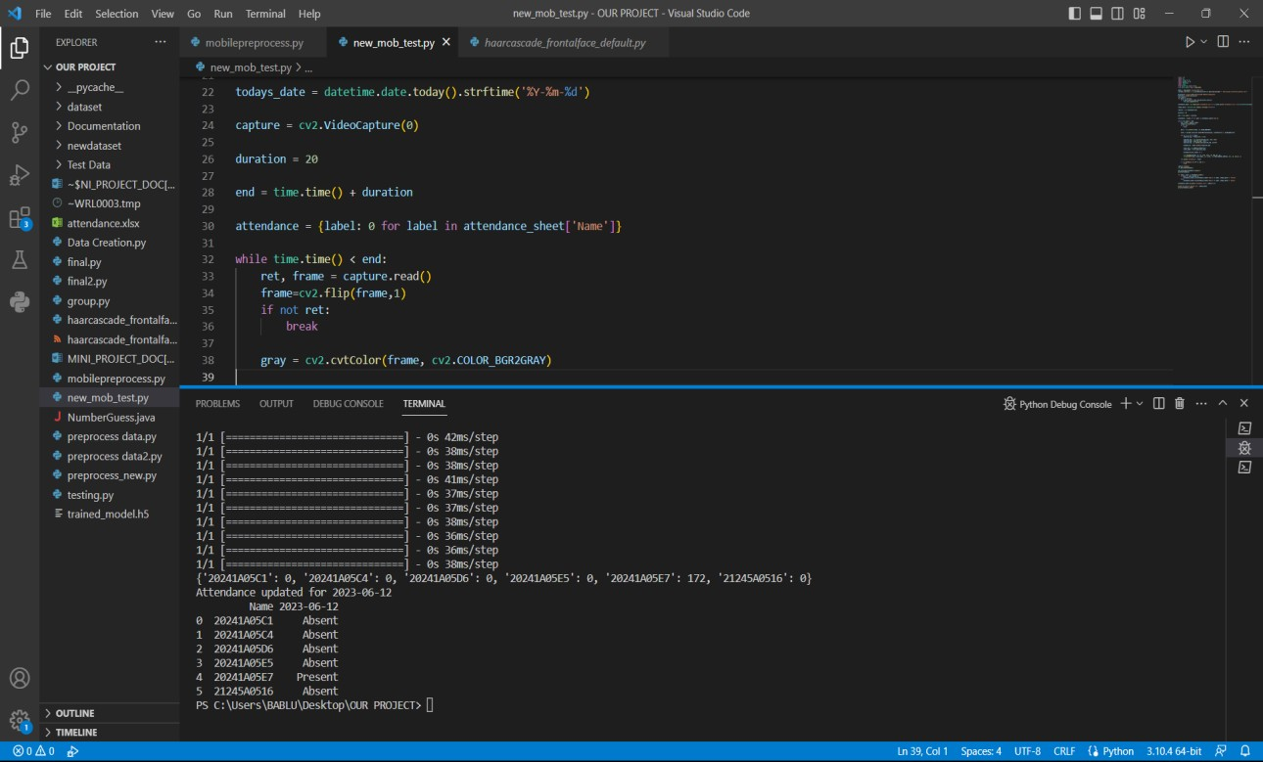

Fig-5.2.2

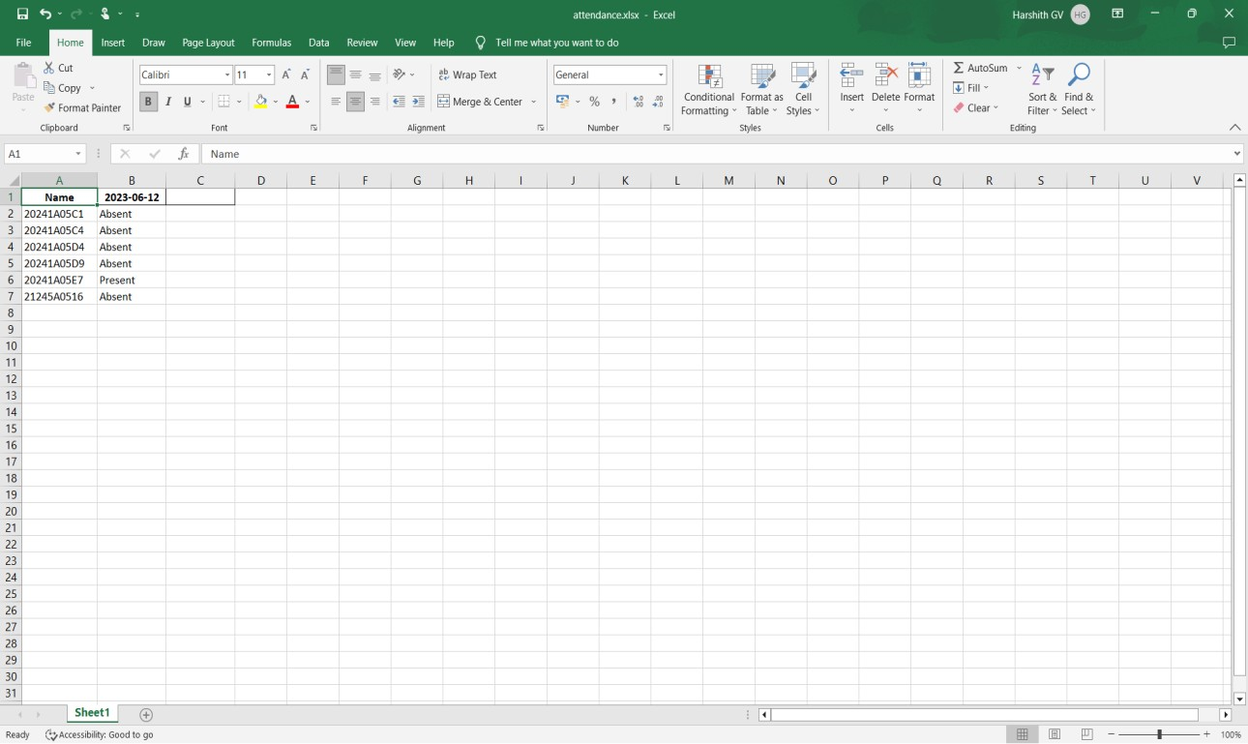

Fig-5.2.3

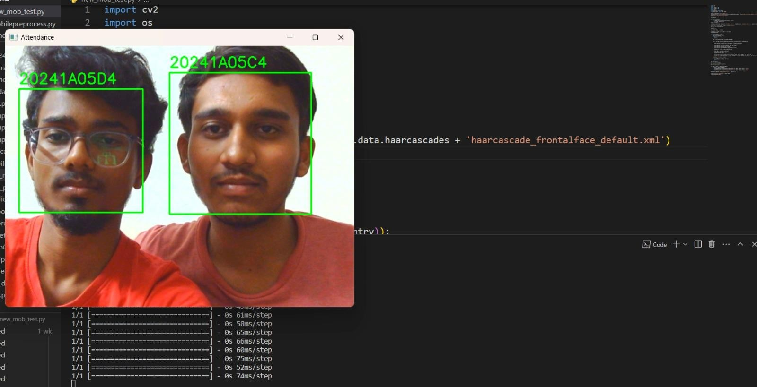

Fig-5.2.4

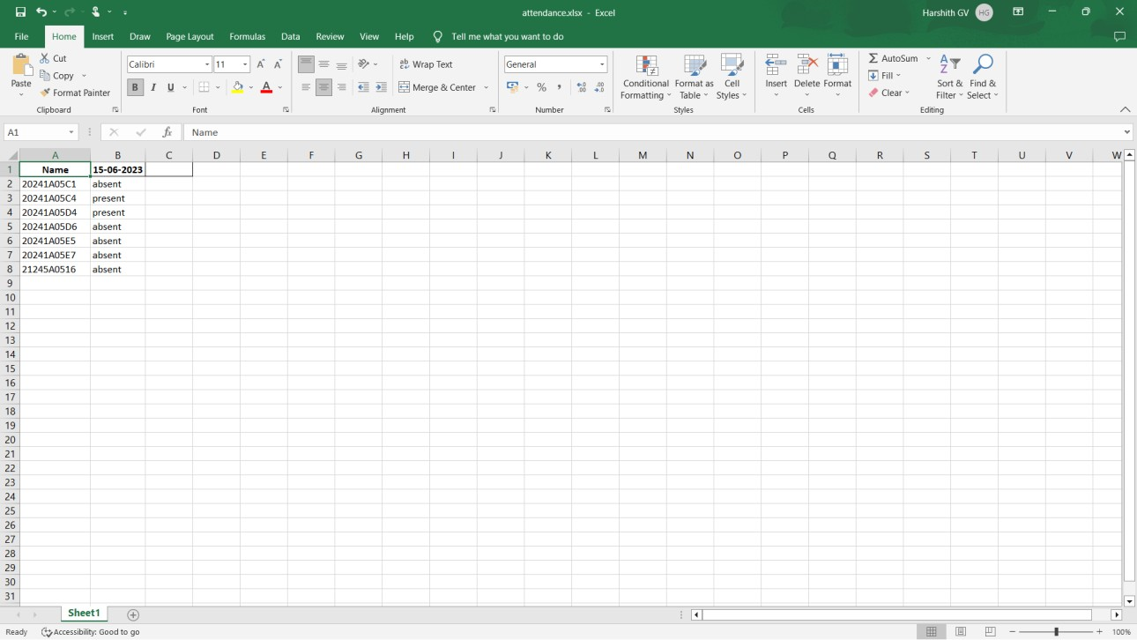

Fig-5.2.5

**CHAPTER 6**

**TEST CASES**

|  |  |  |  |  |  |  |  |  |
| --- | --- | --- | --- | --- | --- | --- | --- | --- |
| **Test Case ID** | **Test Scenario** | **Test Case** | **Preconditi ons** | **Test steps** | **Test Data** | **Expected Results** | **Actual Results** | **Status Pass/F ail** |
| 1 | Single person | Scanning a single face | Trained CNN(Mo  bileNetV2  ) model | Initializing the camera and scanning the person by detecting the face | Dataset containing the images of the person in all positions | Person roll number should be displayed and mark present in the excel  sheet. | Person roll number is displayed on the screen and marked present for the person in the excel  sheet. | Pass |
| 2 | Multiple persons | Scanning the multiple faces present in front of the camera | Trained CNN(Mo  bileNetV2  ) model | Initialize the camera and scan the persons by detecting the faces. | Dataset containing the images of the persons in the folders with the persons roll number. | Persons roll number should be displayed on the persons faces and mark the attendance in the excel sheet for the detected  faces. | Persons roll number is displayed on the persons faces and marked present for the persons in the excel sheet. | Pass |
| 3 | Unknow n Persons | Scanning the multiple faces present in front of the  camera | Trained CNN(Mo  bileNetV2  ) model | Initialize the camera and scan the persons by detecting the faces. | Dataset containing the images of the persons in the folders with the persons roll number. | The unknown persons should not be detected. | The unknown persons who are not in the dataset are not detected. | Pass |

## CHAPTER 7

## CONCLUSION& FUTURE SCOPE:

* + It streamlines the attendance process, improves accuracy, enhances convenience, and strengthens security.
  + Its implementation benefits educational institutions, and businesses by optimizing attendance management and enabling more efficient resource allocation.
  + The scope of smart attendance management can vary depending upon the specific requirements of an organization.
  + It can be implemented in various settings such as schools, universities, work places, or events, to efficiently manage attendance and enhance security.
  + Extend the system to support multiple cameras, enabling attendance tracking in larger areas or multiple locations simultaneously.
  + The smart attendance management system using MobileNetV2 has proven to be effective in automating the attendance tracking process.
  + The system offers convenience and efficiency by eliminating the need for manual attendance marking, reducing human error, and saving time.
  + It can be integrated to the attendance management system with existing student information systems or databases to streamline data management.

## 

## REFERENCES:

The research paper titled "Face Recognition Based Student Attendance System with OpenCV" was authored by Ch. Vinod Kumar and Dr. K. Raja Kumar. Ch. Vinod Kumar is currently a PG Scholar in the Department of Computer Science and Software Engineering at Andhra University in Vishakhapatnam, AP, India. In another study titled "Smart Attendance System using Computer Vision and Machine

Learning," Dipti Kumbhar and Prof. Dr. Y. S. Angal conducted the research. Dipti Kumbhar is

associated with the Department of Electronics and Telecommunication at BSIOTR in Wagholi, Pune, India. The contact email for Dipti Kumbhar is [diptikumbhar37@gmail.com,](mailto:diptikumbhar37@gmail.com) and the contact email for Prof. Dr. Y. S. Angal is [yogeshangal@yahoo.co.in.](mailto:yogeshangal@yahoo.co.in)

## Acronyms:

###### OpenCV:

Open-Source Computer Vision.

###### CNN:

Convolutional Neural Network.

**NumPy:** Numerical Python.



